Creating and Using a Sign-Up Genius as a Room Parent Tool

Sign-Up Genius is an online tool used to create, organize, and share responsibilities for various events. Other online tools exist that do similar things such as Jooners or mysignup.com. Since I do not have any experience with any other online-scheduling tool like this, these instructions are restricted to Sign-Up Genius only.
Sign-Up Genius is free (though a paid option exists). If this is your first time using Sign-Up Genius, you will need to create an account.

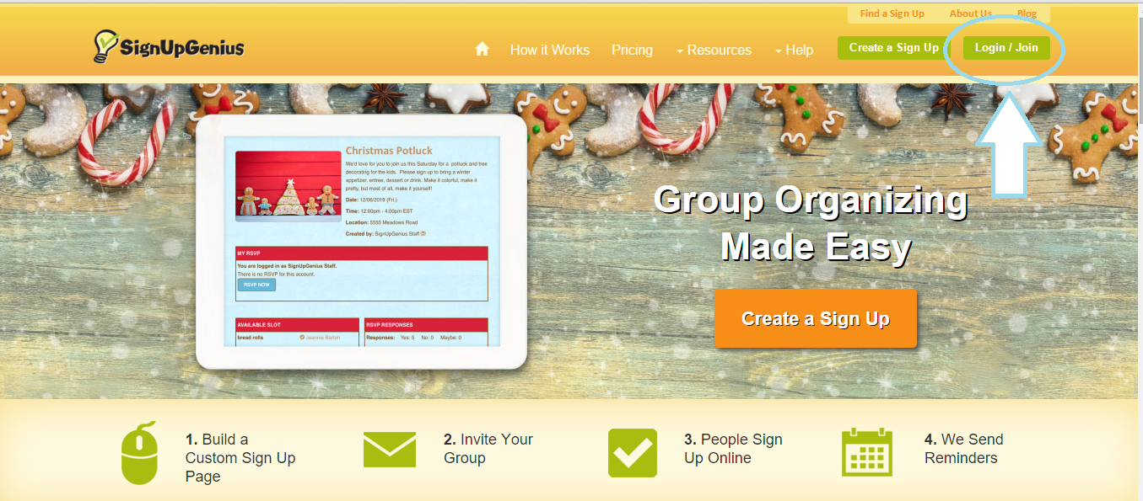
Step 1: Go to www.signupgenius.com and click Login/Join in the top right-hand corner of the screen.

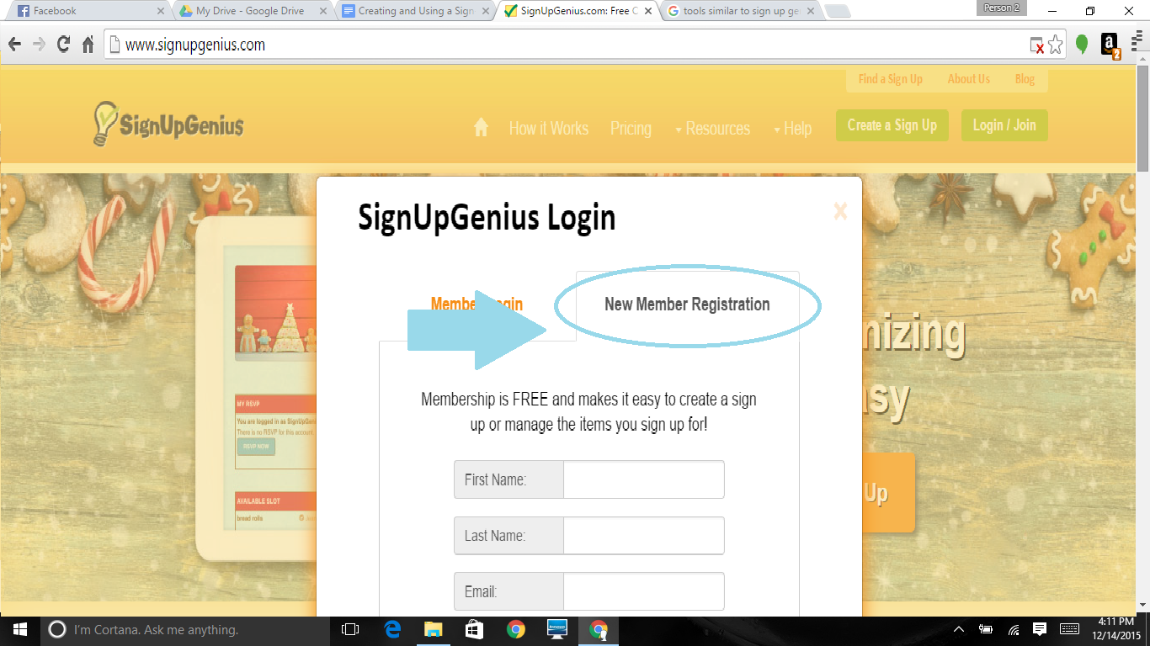
2. Click New Member Registration and complete the registration information. Sign-Up Genius is free and should not cost you anything.

Once you have created your Sign-Up Genius account, you can now begin creating your own Sign-Up Geniuses.

3. Log in to your Sign-Up Genius account and it should take you to a screen similar to this:
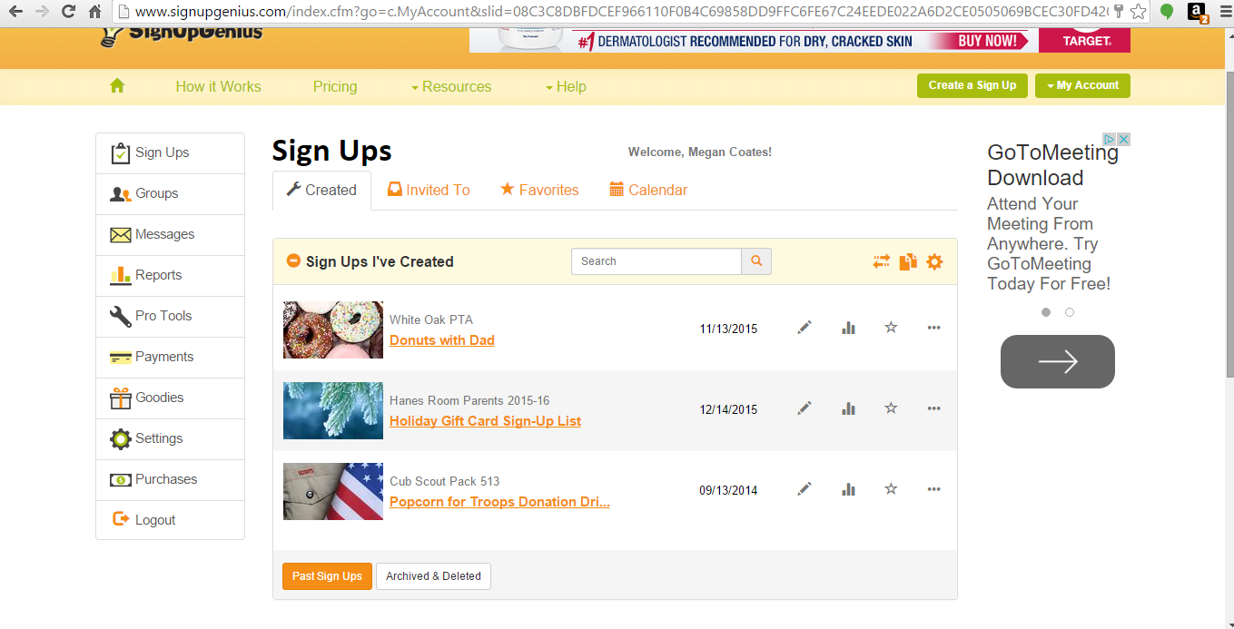
This is your Sign-Up Genius dashboard and will show you sign-ups that you’ve created on the front page. If you have not created any sign-ups, you will see nothing on this page.
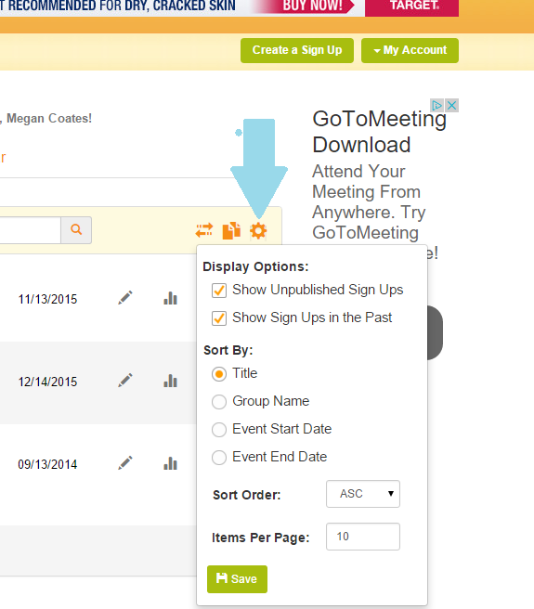
Click on the little dial/sun symbol on the right and make sure that “Show Unpublished Sign Ups” and “Show Sign Ups in the Past” are both checked. This will make it easier for you to find
any sign-ups that you create.

4. Find the button on the top right labeled “Create a Sign Up” and click it.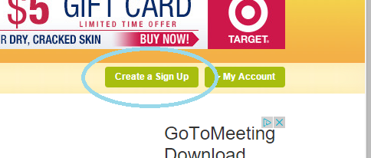

5. Create a Sign-Up Genius.
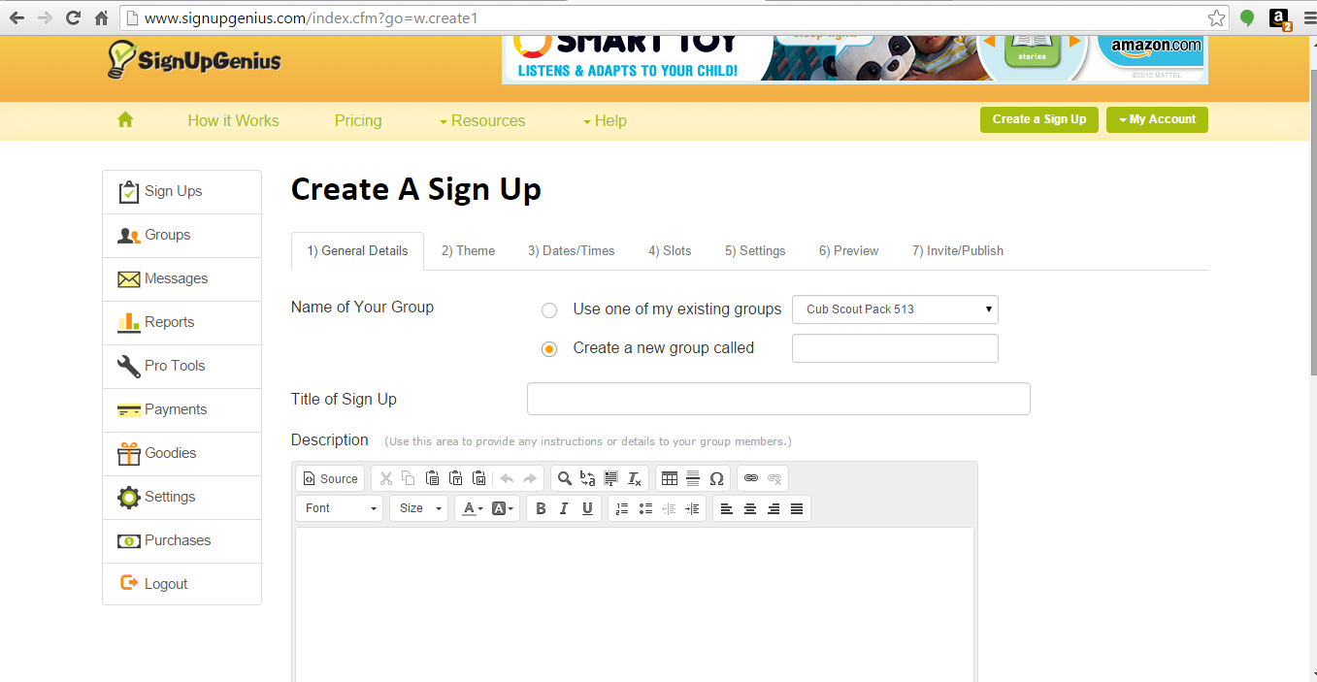

If you have never created a sign-up, you will need to create a new group and name it. Once you have created this group, it will be saved and you can use it again. Title your sign-up and give it a description.
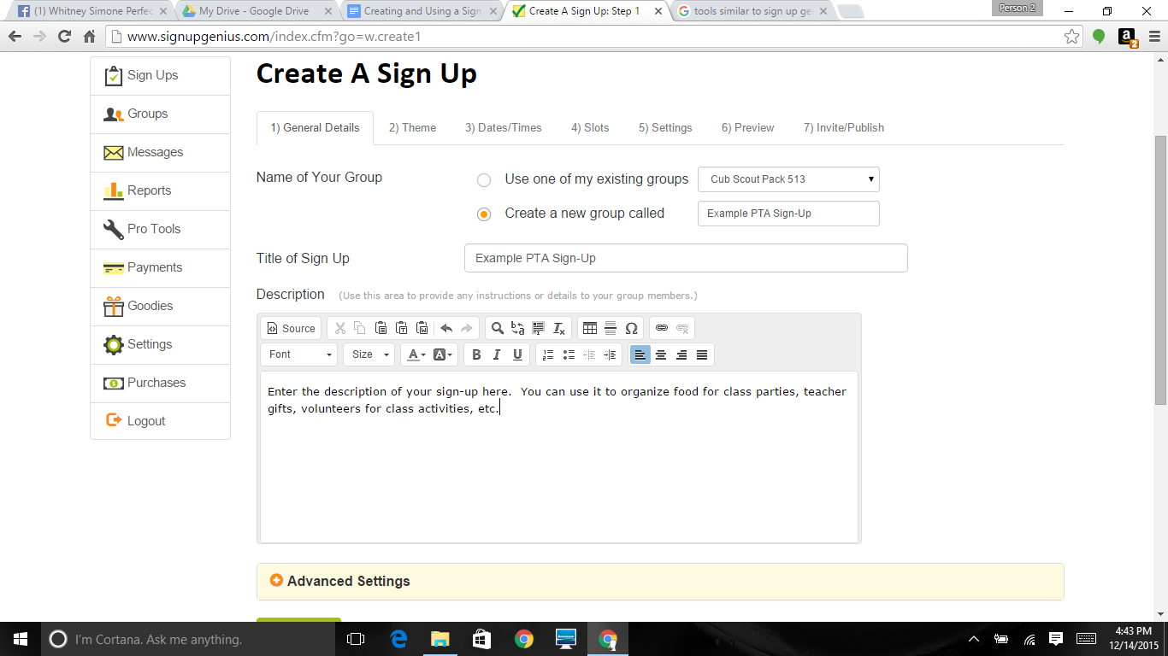

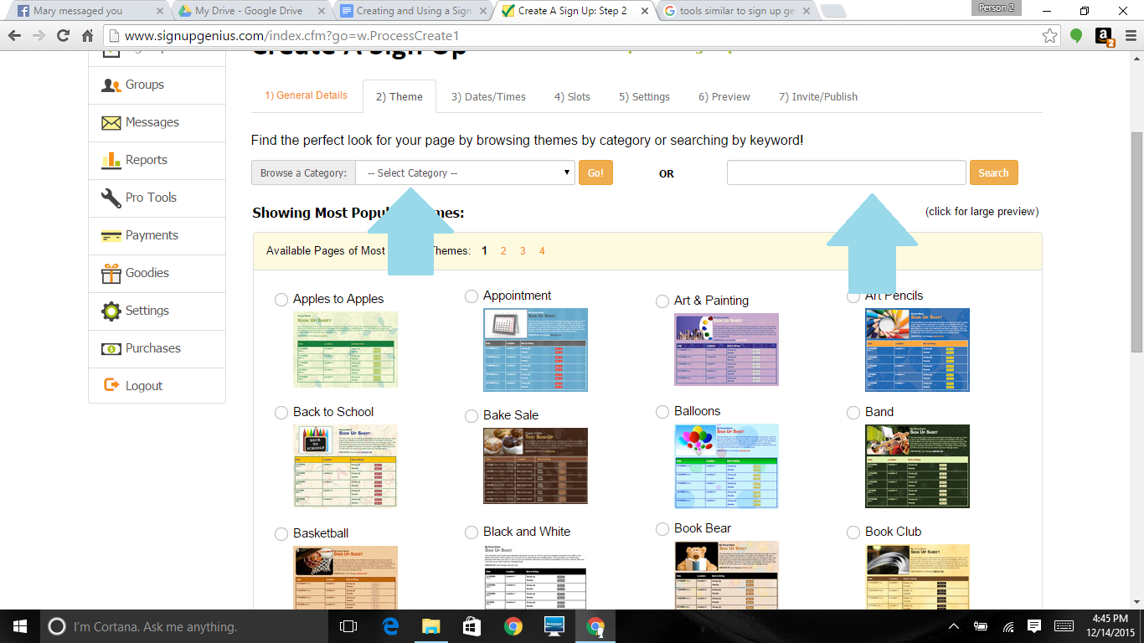
6. Click “Continue” at the bottom of the page and advance to tab 2, “Theme”. Themes allow you to customize the background and pictures associated with your sign-up. There are tons and tons of themes you can use for free. You can also browse by category or enter a keyword.

For our purposes, I’m going to select a party theme. Choose your theme and click “Continue” at the bottom of the page to move on to tab 3, Dates/Times.

7. Choose the type of sign-up that works best for the event you are having. Generally, I use “One-time” or “No specific date” most frequently. For this example, I’m going to use the “one-time” sign-up type.
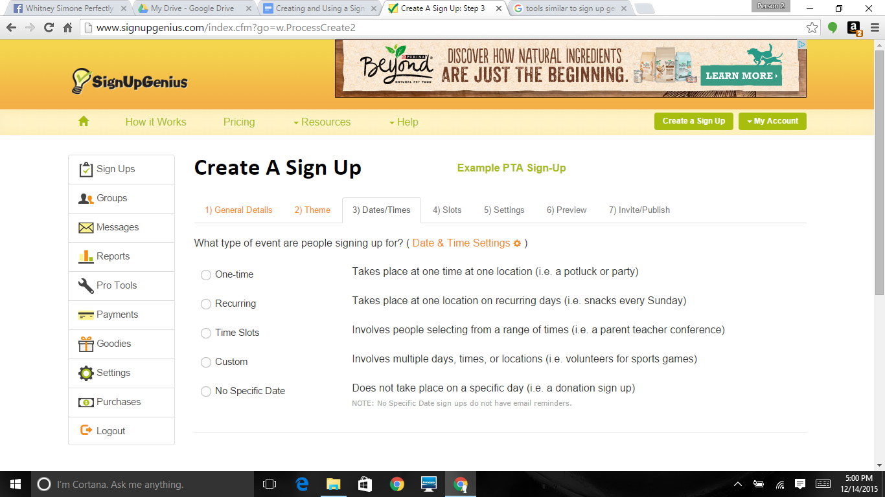
Once you select your event type, more fields will pop up at the bottom of the screen to fill out the specific date, times, and location of your event.
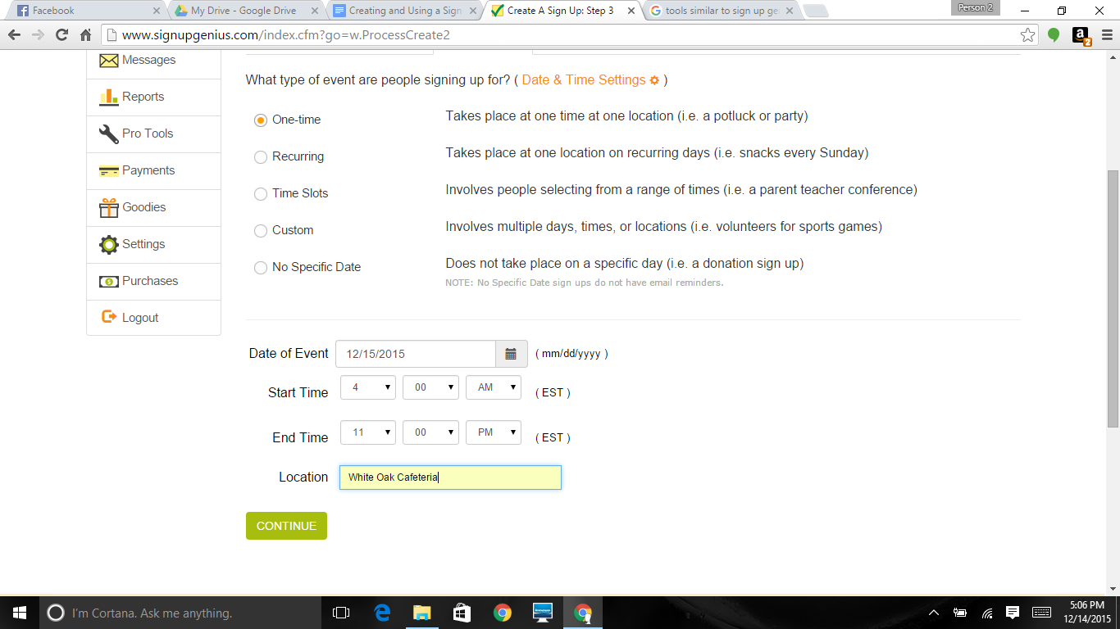

Fill out this information and click “Continue”.

8. Tab 4 allows you to specify what you need and how many you need of that item or volunteer.
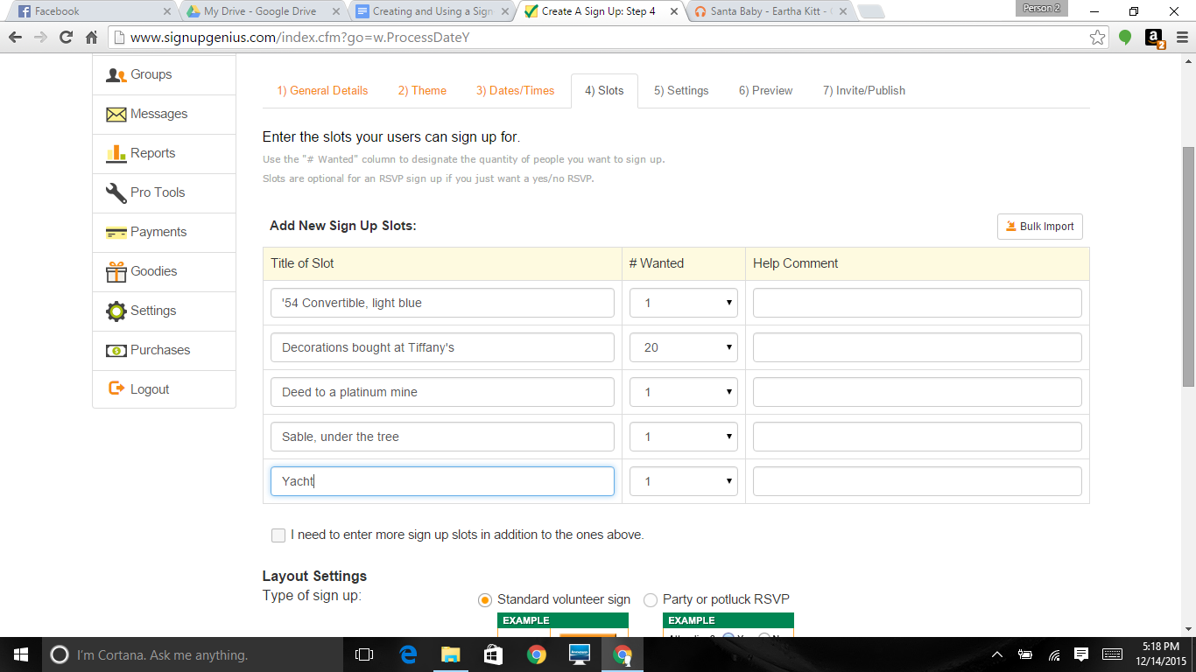
The default gives you 5 slots, but there is a check box that will allow you to add additional slots to your sign-up. There are also two layout settings at the bottom: “standard” and “party or potluck rsvp”. I have only ever had to use standard. Fill in your slots and click “Continue”.

9. Tab 5 “Settings” allows you to tweak some contact information. I typically leave the name/email/phone/address contact information on the default settings.
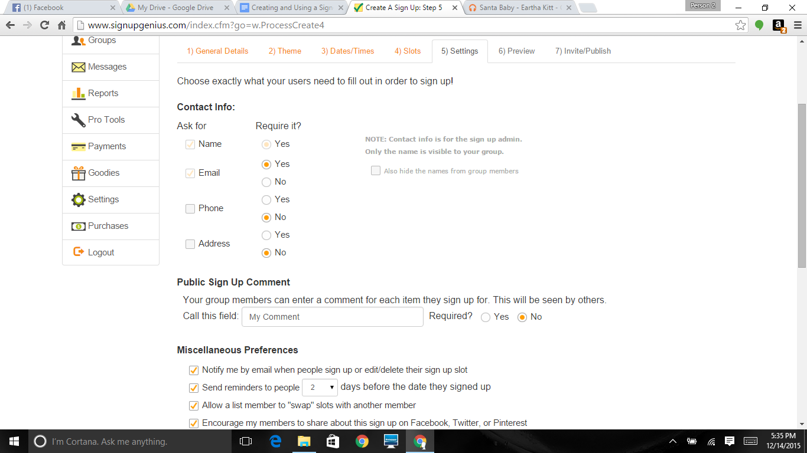

The main settings you’re most interested in are the “Miscellaneous Preferences”.
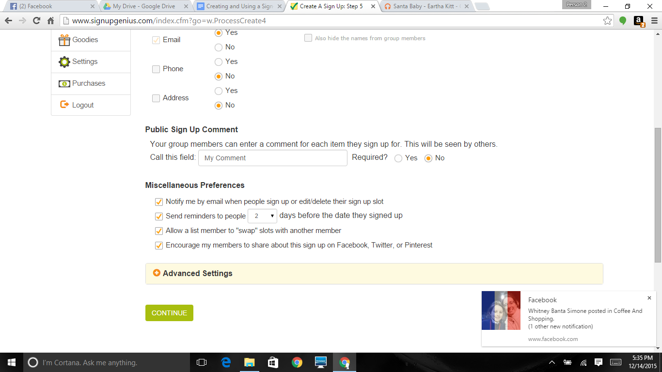

If you choose to uncheck ANY of the Miscellaneous Preferences boxes, I would STRONGLY encourage you to leave the “Send reminders to people x days before the date they signed up” box alone. One of the beauties of Sign-Up Genius is that it reminds people for you so you don’t have remind people what they have signed up for. Just to be clear: DO NOT UNCHECK THE SEND REMINDERS TO PEOPLE BOX! Click “Continue”.

10. Tab 6 is the Preview screen. Your sign-up will not go live until you click on “Proceed to invite and publish” on the left-hand side of the screen.
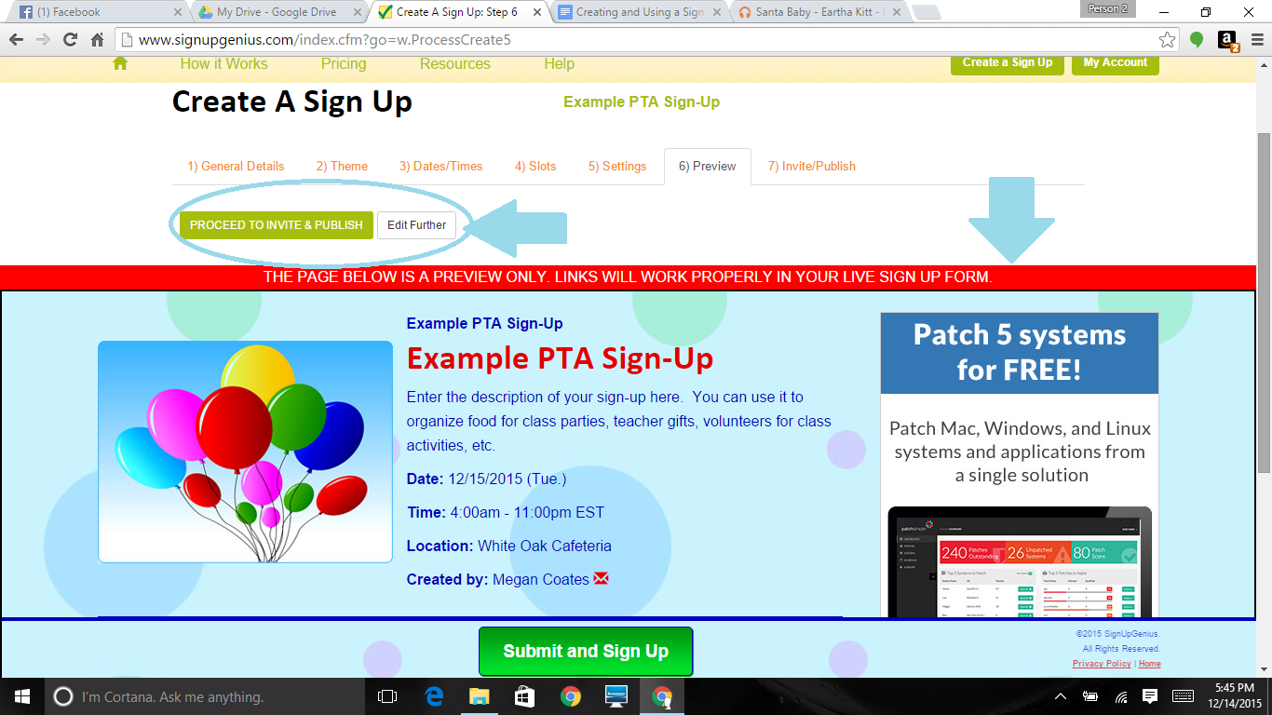
Notice that the theme I selected has been applied at this point. This is your opportunity to check your spelling, your times, your location, etc. before you send it out to people.
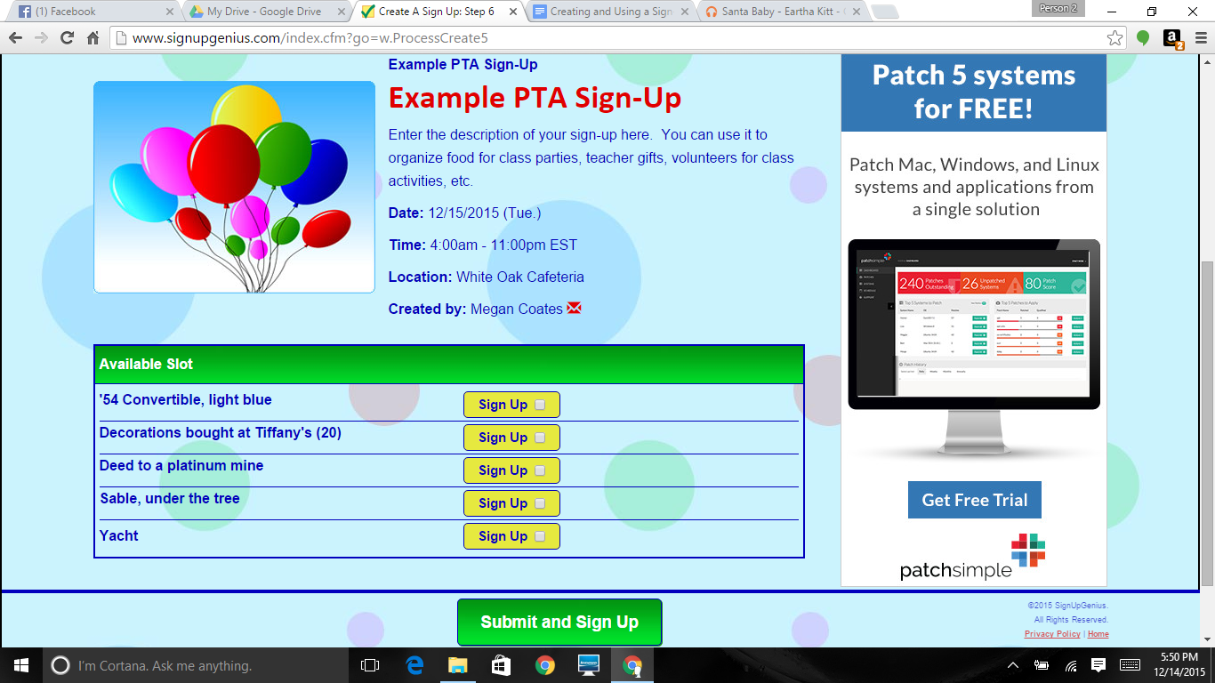

Once you are confident that this is what you want, click “Proceed to invite and publish”. If you want to make changes, click “Edit further”.

11. The final tab is Invite/Publish. Here, you choose how you want to enter your emails (you can either enter them manually or you can import them from an address book if you’ve created a group for your room parents in your address book).
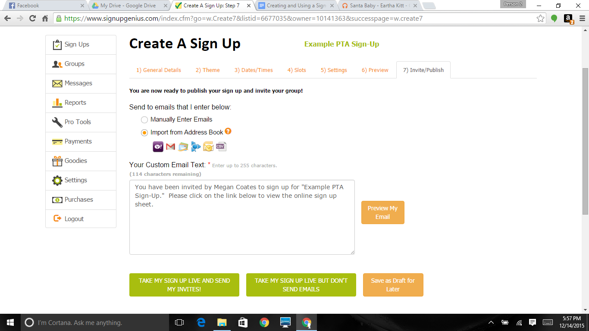

Once you enter your email addresses, you can choose to do one of three things: 1) Publish your Sign-Up and send your emails, 2) Publish your Sign-Up but NOT send your emails (I have no idea why you would ever want to do this), or 3) Save as a draft for later.

12. After you publish your sign-up, you’ll get a screen like this:
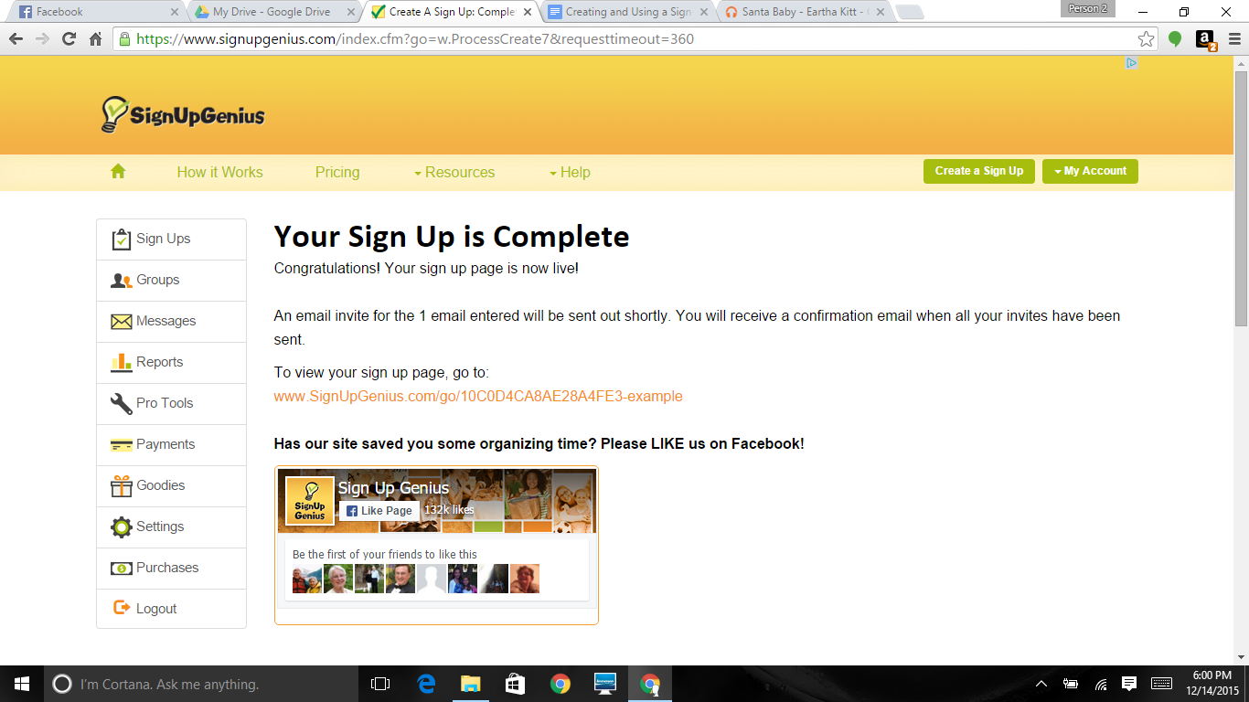
Included is a link where you can view your sign-up, but this will come in your email as well.

Congratulations! You’ve completed your first Sign-Up Genius. I hope you found this very basic tutorial helpful.

Thank you all for your time and effort!

